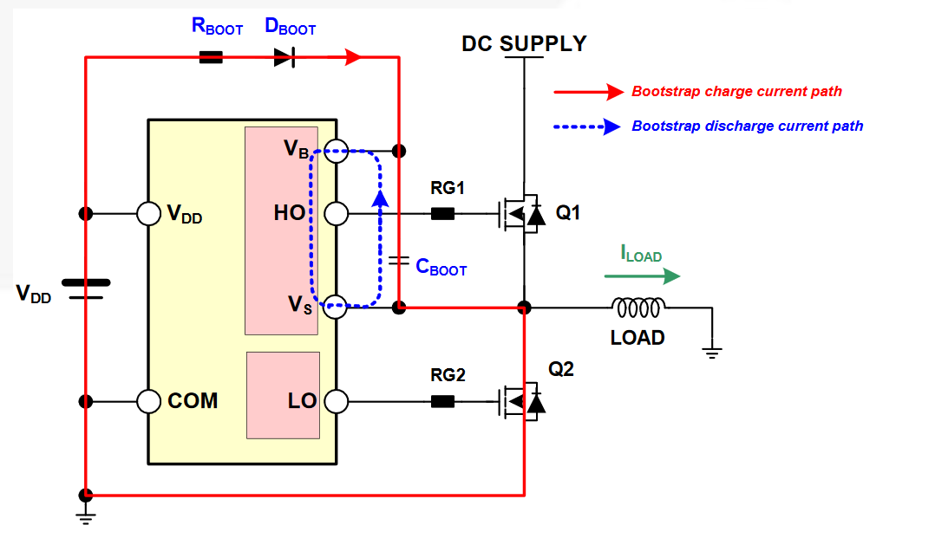

Figure 1: Bootstrap Circuit

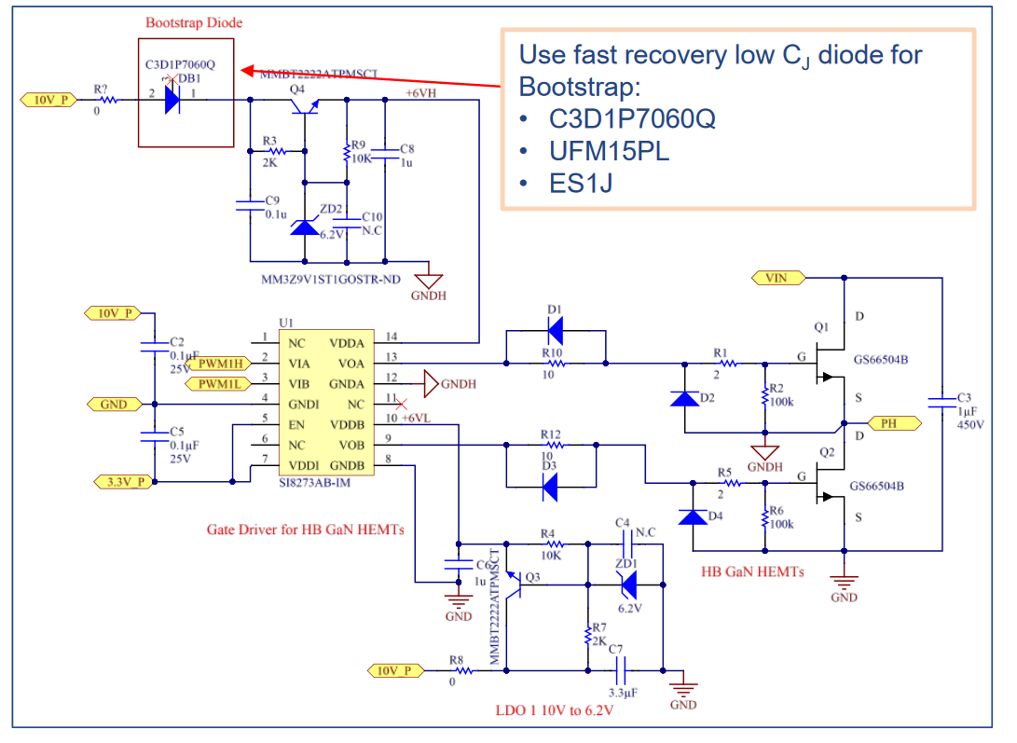

Figure 2: Recommended Bootstrap Driver

# Pros and Cons

+ Simple Circuit just a capacitor-diode

+ Cost

+ PCB area

* Charging and discharging oscillations
* Duty cycle limitations
* Required to use Source pin of GaN instead of Kelvin
* Starting strategy for 2 parallel 2 series concept
* Less slew rate

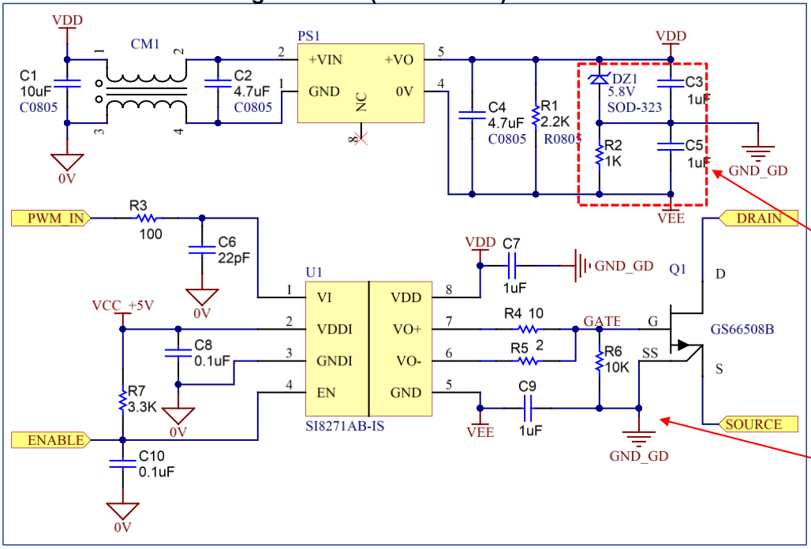

Figure 3: Single Isolated Gate Driver